An accessible walk: Plymbridge Woods to Shaugh Tunnel on Drakes Trail
Dawn Williamson. Moorland Guides and Wheeled Access Group.
This is an out and back walk beginning and ending at the National Trust Car Park in Plymbridge Woods. It is 4.2 miles from the car park at Plymbridge to Shaugh Tunnel though you can turn round at any time on the route.
The route simply follows the old railway line.
I described the northern section of the line, from Shaugh Tunnel to Yelverton, in a Moorlander article a few months ago.
Most of the route has a tarmac or concrete surface. Comfortable and easy for wheels and is therefore suitable for cyclists, people pushing pushchairs, and those using electric wheelchairs and mobility scooters. It has been reccied by the Wheeled Access Group.
This walk forms a part of Drakes Trail, a 21 miles cycle and walking route linking Tavistock and Plymouth. It takes its name from Sir Francis Drake, linking places featured in his life. It was opened for cyclists and walkers in 2009.
This route is also part of National Cycle Route 27, a 102 mile route beginning in Ilfracombe in North Devon and ending in Plymouth. You will be following the NCN 27 signs along this walk.
You will start at the car park at Plymbridge Woods. The woods are managed by the National Trust.
From the carpark walk up the incline, passing the platform of the Plym Valley Railway and onto the tarmac path. The Plym Valley Railway was founded in 1980, aiming to restore part of the ex-Great Western branch line from Plymouth to Tavistock that was closed in 1962. It runs from Marsh Mills. The station at Plymbridge was opened in 2012. Trains now run on a Sunday.
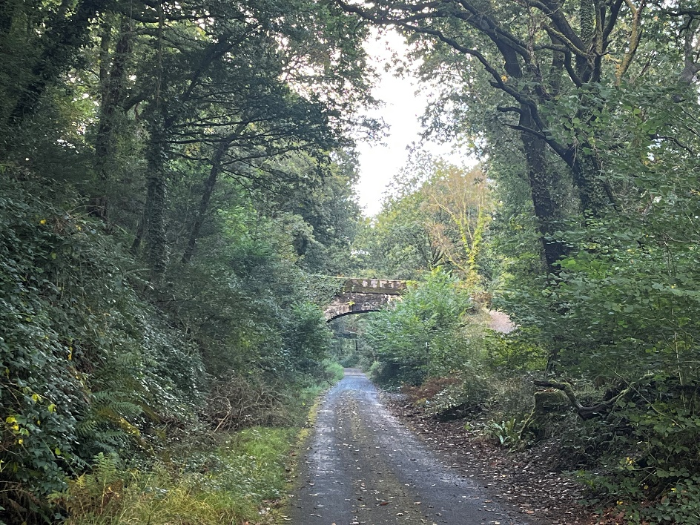
Below you will see the canal which was constructed in 1829 to transport slate from Cann quarry using box-shaped barges pulled by horses. It was later used as a leat for Marsh Mills.
Plymbridge woods are only 110 years old, planted to supply timber. Each compartment of the woods had a single species which is not nature friendly. These compartments are now being thinned and replanted with a variety of species.
You will be following the old railway line. The South Devon and Tavistock railway with a standard 4ft 8-inch gauge opened in 1859 after a delay due to the Crimean War. Isambard Kingdom Brunel was the engineer for the line. It closed in 1962.
After walking under a stone bridge you'll see the ruins of railway cottages on your right. These were built to house quarry workers. The railway cottages were first mentioned in 1795 in a lease for Cann Quarry which you will pass shortly. In 1896, Edward Gullett, the tenant of Cann Quarry, converted the two remaining cottages into one large home for his family. Behind the cottages were a range of pig sties, and around the front and sides were gardens where tea was served to day trippers. About a mile from Plymbridge you will pass a metal milepost erected to commemorate the establishment of the National Cycle Network. One thousand of these were erected around the country.
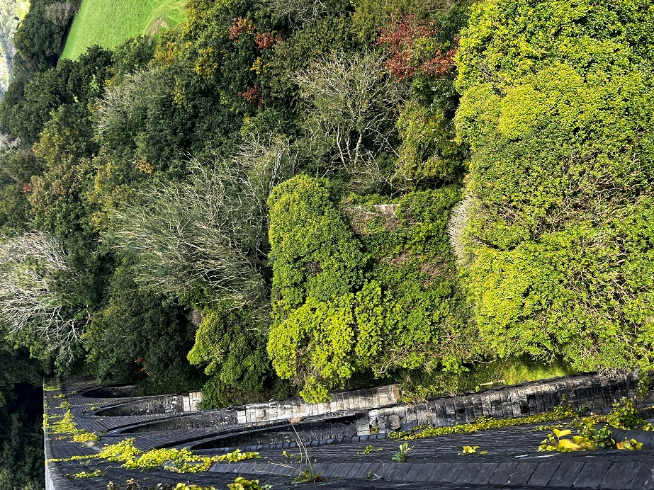
Continue along the track onto the viaduct, which was built in 1907 to replace an earlier version engineered by Augustus Bampton and Isambard Kingdom Brunel. The stone bases of the original viaduct can still be seen.

There are telescopes on the viaduct during the nesting season as part of the Plym Peregrine project which was started in 2001. There have been breeding peregrine falcons at Cann Quarry for at least 50 years. Since then, 34 chicks have successfully left the nest and some of the young have been recorded at other locations raising their own chicks
You will go over a second viaduct with great views to Dartmoor and the clay works at Lee Moor. Lee Moor clay works have been producing Kaolin since the 1830s and has been an important industry on the moor since that time. Koalin is formed from feldspar in the granite.

Woodland
Plymbridge to Shaugh Tunnel, an accessible walk
To Clearbrook
Plymbridge Woods National Trust Car park
To Plympton
Ruined cottages
Viaduct
Viaduct
Shaugh Tunnel
Drakes Trail
River Plym
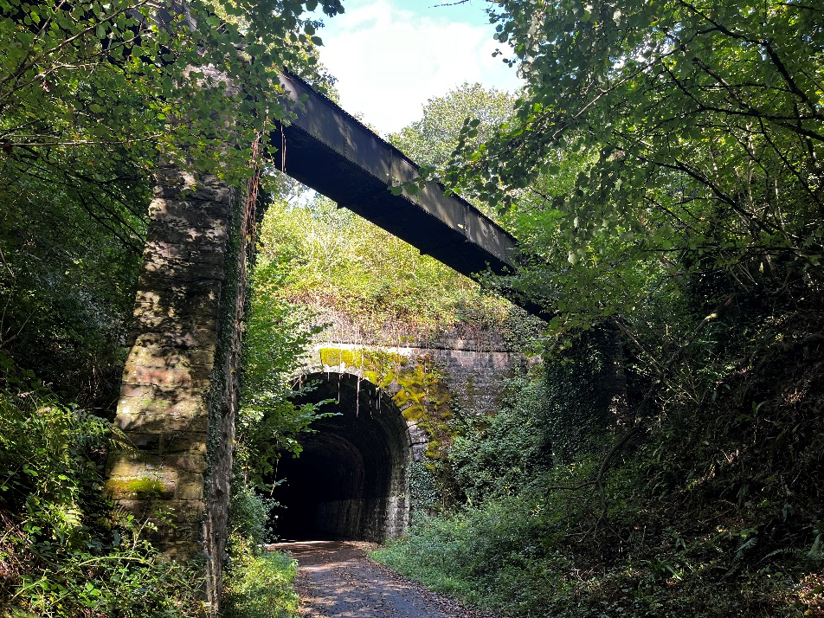
Stop for a while in the cuttings with their steep sides which are often damp and covered with mosses and ferns. These ferns are among the most ancient plants we have on Earth. They evolved long before flowing plants.
Along much of the route are broad leaved woodlands. These trees overhang the track and cover the valleys you can see from the viaducts providing different views and colours through the year.
After 4.2 miles you will reach Shaugh tunnel which is also known as Drakes Leat Tunnel or Leighbeer Tunnel. It is 300 yards long and carved out of solid rock. It was designed by I.K. Brunel. There is usually water dripping from the roof and although the tunnel is lit it is helpful to carry a torch so people coming in the other direction can see you.

During the 2nd World War the top of the tunnel was used as a base for defensive guns. These were used to protect RAF Harrowbeer on the outskirts of Yelverton.
Just before the tunnel there is a bench on your right with lovely views across the fields. Once you have reached the tunnel (or walked through the tunnel), turn around and retrace your steps to Plymbridge woods.

If you would like any further information about the Wheeled Access Group, please visit www.dartmoorwags.org.uk

